RCB IPL Strategy — Task Sheet
Instructions: Do not change the question text. Write your answer directly below each question. For Objective questions, the expected output columns and row counts are given below the question. For Subjective questions, no such details are given, work out and write the answer on your own.

Objective Questions
Q1 List the different dtypes of columns in table "ball_by_ball" (using information schema)
Output columns (in order): COLUMN_NAME, DATA_TYPE, IS_NULLABLE, COLUMN_KEY (4 columns)
Row count: 11 rows.

Used INFORMATION_SCHEMA.COLUMNS to retrieve the columns and information of the ball_by_ball table, including column name, data type, nullability, and key information.
All the columns in ball_by_ball table are of integer datatype consisting numbers. It also has 4 columns which are primary key.

SQL Query:
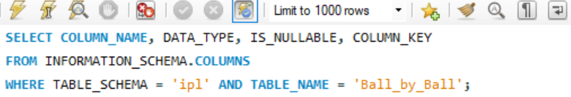

Output:
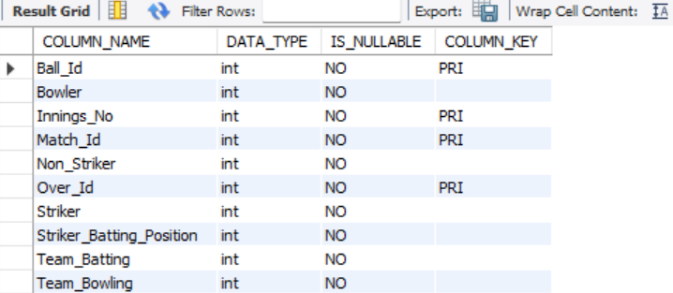

Q2 What is the total number of runs scored in 1st season by RCB (bonus: also include the extra runs using the extra runs table)
Output columns (in order): bat_runs, extra_runs, total_with_extras (3 columns)
Row count: 1 row (single aggregate row).

To get total number of runs scored in 1st season by RCB, 4 tables have been used i.e:
- Batsman_Scored – to get the runs scored by the team
- Ball_by_Ball – to get match, over, ball & innings detail
- Matches – to get match & season details
- Extra_Runs – to fetch extra runs by the team
JOINS concept has been used to join the above tables such as-
Batsman_Scored with Ball_by_Ball on – match_id, over_id, ball_id, innings_no
Ball_by_Ball with Matches on – match_id
Matches with Extra_Runs on – match_id, over_id, ball_id, innings_no

SQL Query: 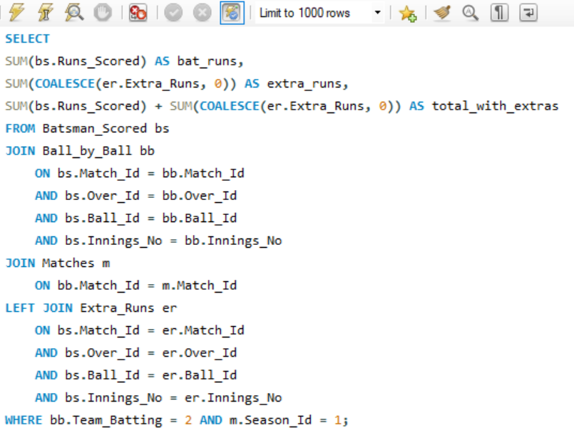

Output:
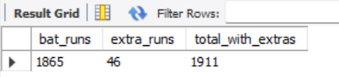

Q3 How many players were more than the age of 25 during season 2014?
Output columns (in order): players_over_25_in_2014 (1 column)
Row count: 1 row (single aggregate row).

To get count of players who were more than the age of 25 during season 2014, 3 tables have been used i.e:
- Player – contains player id and DOB
- Player_Match – get details about matches played by the players
- Matches – get season details
- Season – contains season year to filter out specific year i.e 2014

JOINS concept has been used to join and get expected details from multiple tables, TIMESTAMPDIFF(YEAR, p.DOB, m.Match_Date) > 25 to filter players older than 25 during entire 2014 season instead of limiting it to any specific date.

SQL Query:
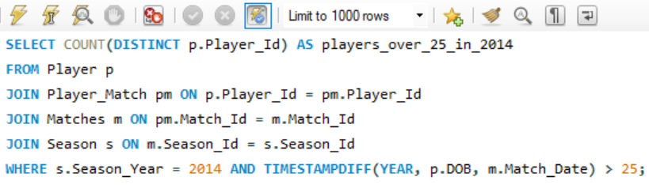

Output:
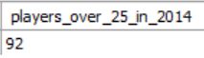

Q4 How many matches did RCB win in 2013?
Output columns (in order): rcb_wins_2013 (1 column)
Row count: 1 row (single aggregate row).
Used the Season table to identify the winning year = 2013, then count the matches where Match_Winner = 2, because RCB has Team_Id = 2.

SQL Query:
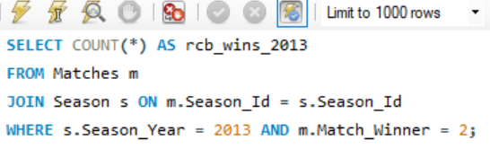

Explanation:
- Matches m → contains match results.
- JOIN Season s → connects each match to its season.
- s.Season_Year = 2013 → keeps only 2013 matches.
- m.Match_Winner = 2 → keeps only matches won by RCB.
- COUNT(*) → counts those winning matches.

Output:
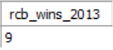

Q5 List the top 10 players according to their strike rate in the last 4 seasons
Output columns (in order): Player_Name, runs, balls_faced, strike_rate (4 columns)
Row count: 10 rows (LIMIT 10).

Seasons lies from 2008 to 2016, so the last 4 seasons are 2013, 2014, 2015 and 2016.
Calculated each player's total runs from Batsman_Scored.
No minimum-ball condition is added because the task does not specify one.
Strike rate Formula: Strike Rate = (Runs / Balls Faced) × 100
Then we sort by strike rate in descending order and return the top 10 players using LIMIT.

SQL Query:
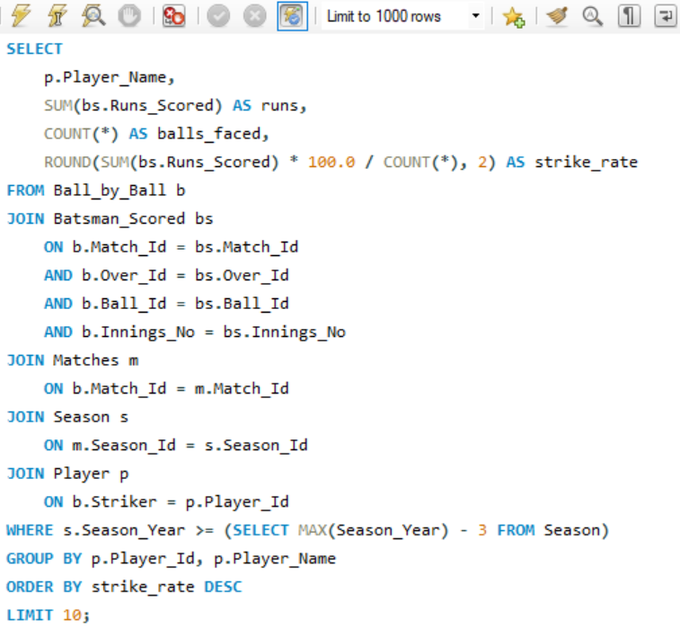

Explanation:
Ball_by_Ball - identifies the batsman through Striker.
Batsman_Scored - provides Runs_Scored.
Matches - connects each delivery to its match.
Season - identifies the season year.
MAX(Season_Year) - 3 selects the last four available seasons: 2013–2016.
SUM(bs.Runs_Scored) calculates total runs.
COUNT(*) calculates balls faced according to the project data.
Strike rate is calculated using (runs × 100) / balls_faced.
ORDER BY strike_rate DESC ranks players from highest to lowest.
LIMIT 10 returns the required 10 players.

Output:
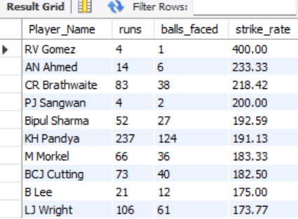
Q6 What are the average runs scored by each batsman considering all the seasons?
Output columns (in order): Player_Name, total_runs, matches, avg_runs_per_match (4 columns)
Row count: 259 rows (1 row per distinct batsman who faced at least 1 ball).

To get the average runs scored by each batsman throughout all seasons, 3 tables has been used i.e:
- Ball_by_Ball - to identify each batsman through Striker
- Batsman_Scored - to calculate their runs.
- Then used GROUP BY to calculate total runs and matches for each batsman.
- ORDER BY to sort the players having highest average runs scored to lowest.

SQL Query:
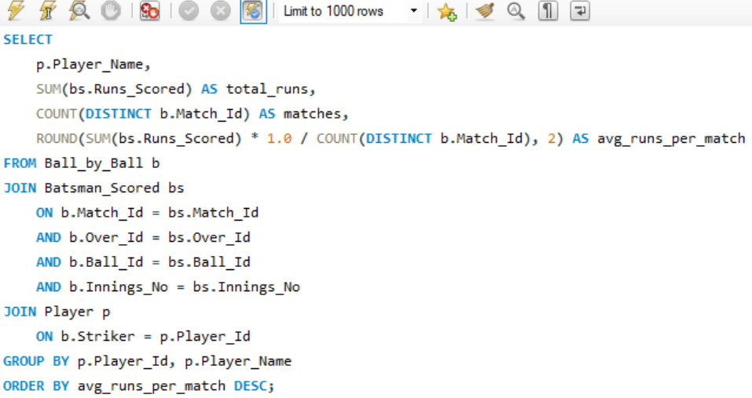

Explanation:
- Ball_by_Ball - identifies the batsman using Striker.
- Batsman_Scored - provides the runs scored by the batsman.
- SUM(bs.Runs_Scored) calculates total runs.
- COUNT(DISTINCT b.Match_Id) counts the number of matches in which the batsman faced at least one ball.
- ROUND() calculates the average runs per match to 2 decimal places.
- GROUP BY creates one row for each batsman.
- ORDER BY sorts players having highest average run scored to lowest.
- No season filter is required because the question considers all seasons.

Output: Limited 10 rows, as original output contains large no of rows i.e 259
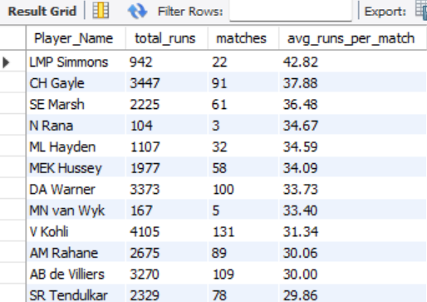

Q7 What are the average wickets taken by each bowler considering all the seasons?
Output columns (in order): Player_Name, total_wickets, matches, avg_wickets_per_match (4 columns)
Row count: 174 rows (1 row per distinct bowler credited with >=1 wicket).

To get average wickets taken by each bowler, 3 tables has been used i.e:
Wicket_Taken – give details of wickets (has bowler_id & match_id etc.)
Player – for bowler names
Ball_by_Ball – to get innings each bowler bowled in.
Average wickets = (Total wickets taken / Number of innings bowled)

SQL Query: 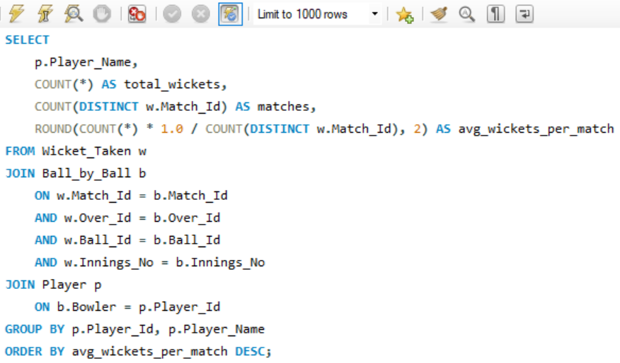

Explanation:
- b.Bowler gives the bowler responsible for that delivery.
- COUNT(*) calculates the bowler’s total recorded wickets.
- COUNT(DISTINCT w.Match_Id) calculates the number of matches in which that bowler recorded a wicket.
- The average is calculated as:
Average wickets = (Total wickets taken / Number of innings bowled)
- GROUP BY gives one row per bowler who has at least one wicket record.
- ORDER BY displays the highest average first.

Output:
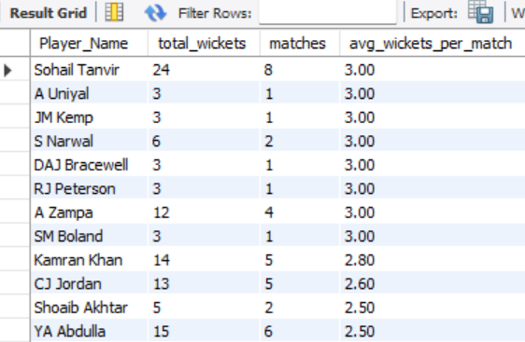

Q8 List all the players who have average runs scored greater than the overall average and who have taken wickets greater than the overall average
Output columns (in order): Player_Name, avg_runs, avg_wkts (3 columns)
Row count: Varies depending on interpretation.

Calculated each player's average runs per innings.
Calculated each player's average wickets per match.
Calculated the overall average of these player-level averages.
Select players whose:
- avg_runs > overall average runs, and
- avg_wkts > overall average wickets.

SQL Query:
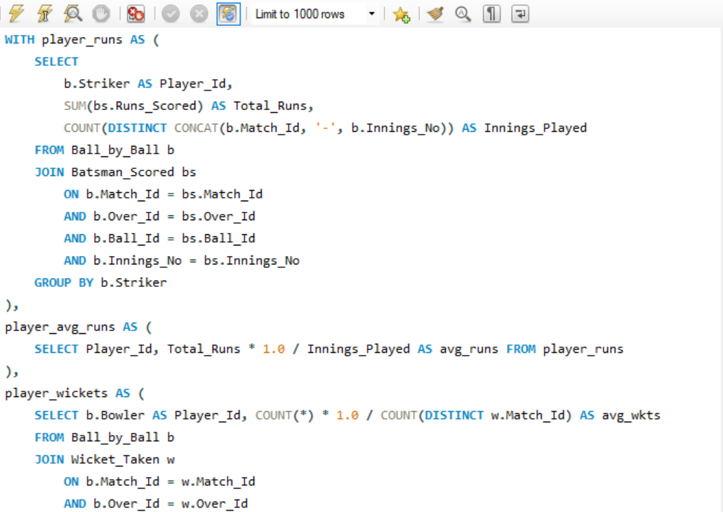
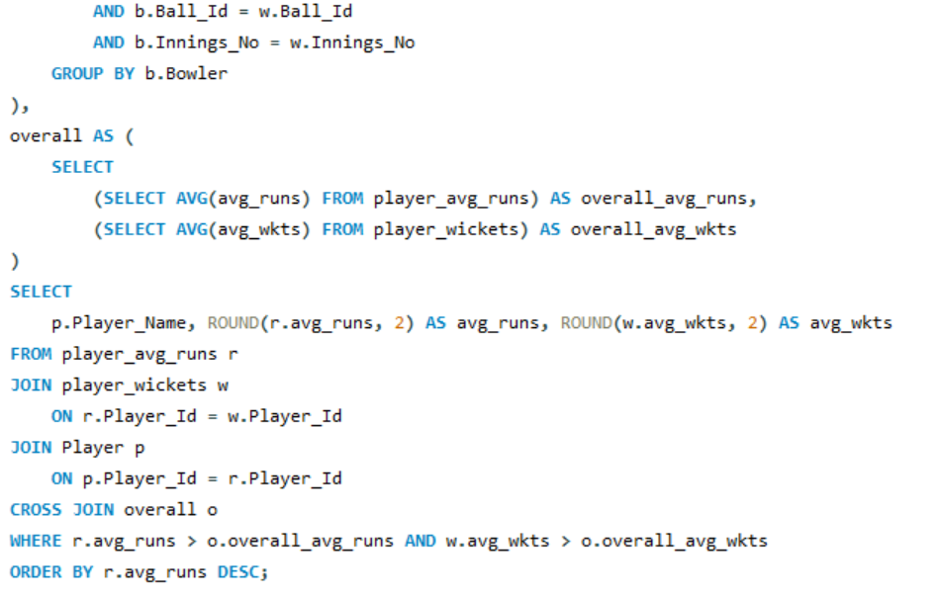

Explanation:
- player_runs - Calculates each player's total runs and number of innings played.
- player_avg_runs - Calculates: Average Runs = Total Runs / Innings Played
- player_wickets - Calculates: Average Wickets = Total Wickets / Matches in which wickets were taken
- overall - Calculates the overall average of the player-level avg_runs and avg_wkts.
- Final WHERE condition:
r.avg_runs > o.overall_avg_runs
AND w.avg_wkts > o.overall_avg_wkts
So only players above both benchmarks are returned.
Output: Limited output, total row count - 37
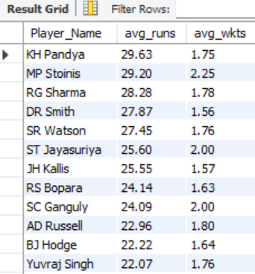

Q9 Create a table rcb_record table that shows the wins and losses of RCB in an individual venue.
Output columns (in order): Venue_Id, Venue_Name, wins, losses (4 columns)
Row count: 18 rows (RCB has played at 18 distinct venues).

RCB has Team_Id = 2 in the data.
Considered matches where RCB participated as either Team_1 or Team_2.
Match_Winner = 2 represents an RCB win.
A non-null Match_Winner other than 2 represents an RCB loss.
Joined Matches Table with Venue Table to obtain Venue_Name.
Grouped the results by Venue_Id and Venue_Name.

SQL Query: 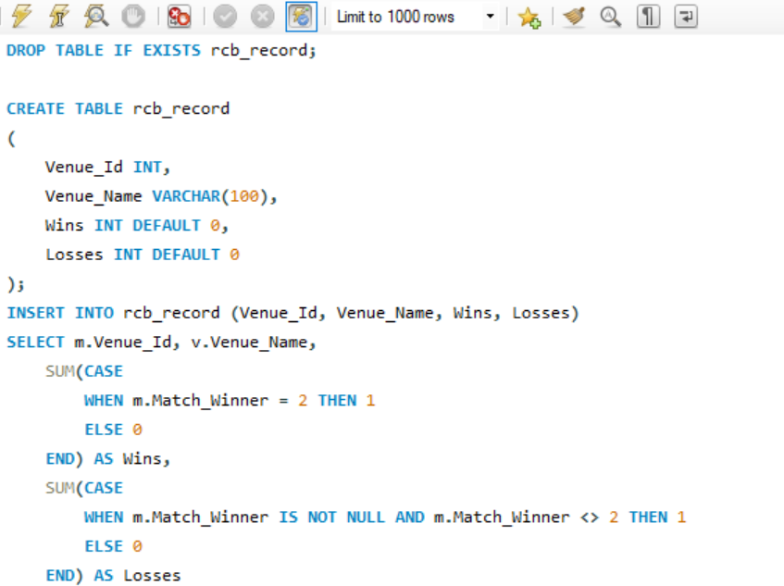
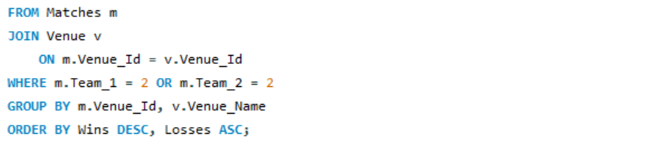
Explanation:
- WHERE m.Team_1 = 2 OR m.Team_2 = 2 - selects only matches in which RCB participated.
- m.Match_Winner = 2 - counts an RCB victory.
- m.Match_Winner IS NOT NULL AND m.Match_Winner <> 2 –
counts matches where RCB participated but another team won.
- The Venue table supplies the corresponding venue name.

Output:
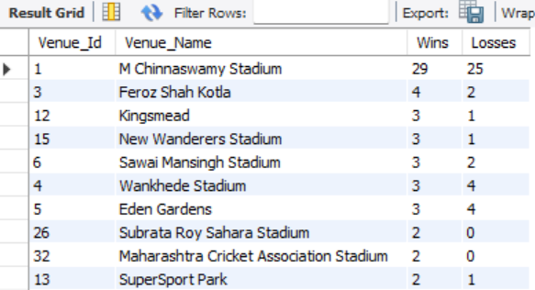

Q10 What is the impact of bowling style on wickets taken?
Output columns (in order): bowling_style, total_wickets, num_bowlers, wickets_per_bowler (4 columns)
Row count: 13 rows (13 distinct bowling styles represented among credited wicket-takers).

Used Wicket_Taken to count the total wickets taken.
Used Ball_by_Ball to identify the bowler for each wicket.
Joined Player to get each player's bowling style ID.
Joined Bowling_Style to get the bowling style name.
Counted distinct bowlers for each bowling style using DISTINCT.
Wickets per Bowler = Number of Bowlers / Total Wickets​

SQL Query: 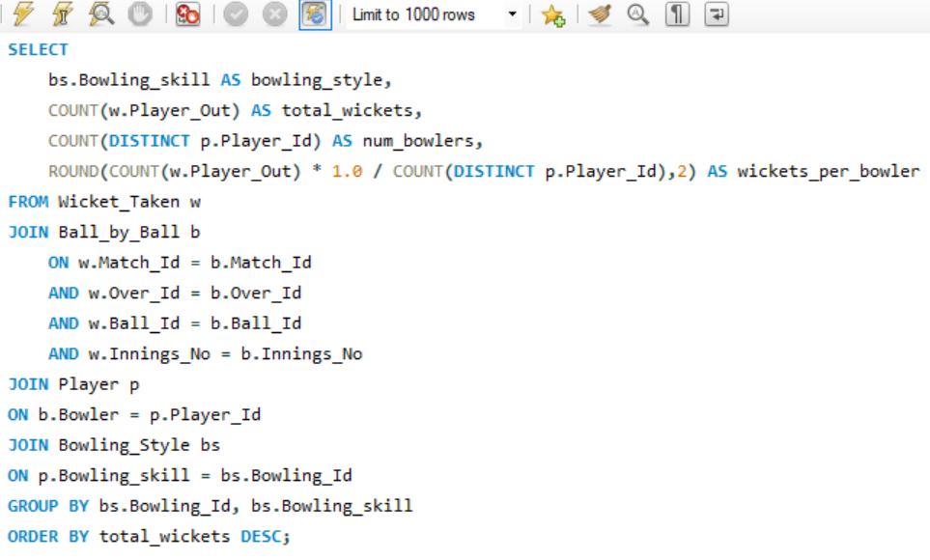

Explanation:
- COUNT(w.Player_Out) - Counts total wickets taken by each bowling style
- COUNT(DISTINCT p.Player_Id) - Counts unique bowlers belonging to that style
- COUNT(w.Player_Out) / COUNT(DISTINCT p.Player_Id) - Calculates average wickets per bowler
- GROUP BY bs.Bowling_Id, bs.Bowling_skill - Groups the results by bowling style
- ORDER BY total_wickets DESC - Shows styles with the highest wickets first

Output: Limited output, total row count - 13
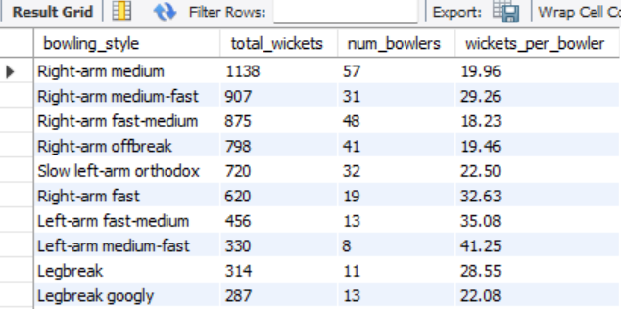
Q11 Write the SQL query to provide a status of whether the performance of the team is better than the previous year's performance on the basis of the number of runs scored by the team in the season and the number of wickets taken
Output columns (in order): Season_Year, runs, wkts, runs_vs_prev, wkts_vs_prev, performance_status (6 columns)
Row count: 4 rows (one per season, 2013–2016).

Calculated total runs scored by RCB in each season.
Calculated total wickets taken by RCB in each season using Team_Bowling = 2.
Used LAG() to get the previous season's runs and wickets.
Calculate:
- runs_vs_prev = current season runs − previous season runs
- wkts_vs_prev = current season wickets − previous season wickets
Classified performance:
- Better → both runs and wickets increased
- Worse → both decreased
- Mixed → one increased and the other decreased
We calculate 2012 internally so that 2013 can correctly be compared with 2012, but display only the required four seasons, 2013–2016.

SQL Query: 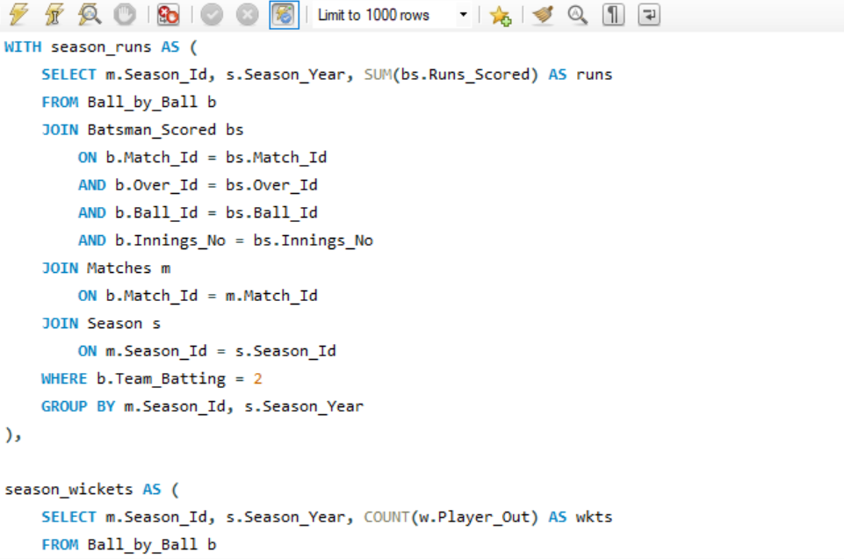
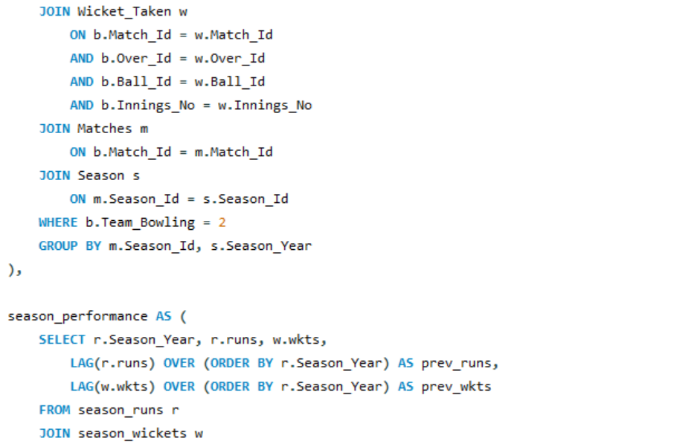
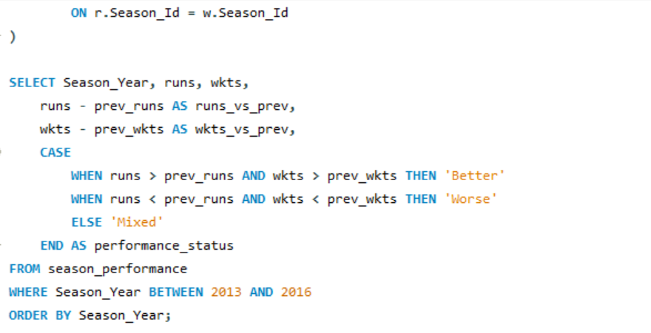

Explanation:
Season_Year - RCB season year
runs - Total runs scored by RCB
wkts - Total wickets taken by RCB
runs_vs_prev - Difference between current and previous season's runs
wkts_vs_prev - Difference between current and previous season's wickets
performance_status - Overall comparison with previous season
LAG(r.runs) OVER (ORDER BY r.Season_Year) - It gives the previous season's runs, allowing 2013 to be compared with 2012, 2014 with 2013, and so on.

Output:
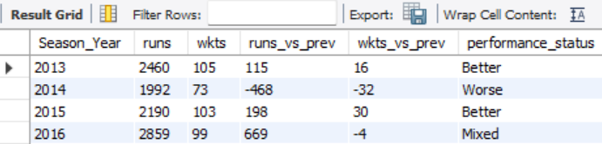

Q12 Can you derive more KPIs for the team strategy?
RCB win % by season
Output columns (in order): Season_Year, played, wins, win_pct (4 columns)
Row count: 4 rows (one per season, 2013–2016).

RCB's Team_Id is 2.
Considered only seasons 2013–2016.
played = number of matches in which RCB participated.
wins = matches where Match_Winner = 2.
win_pct = (wins / played) × 100.

SQL Query: 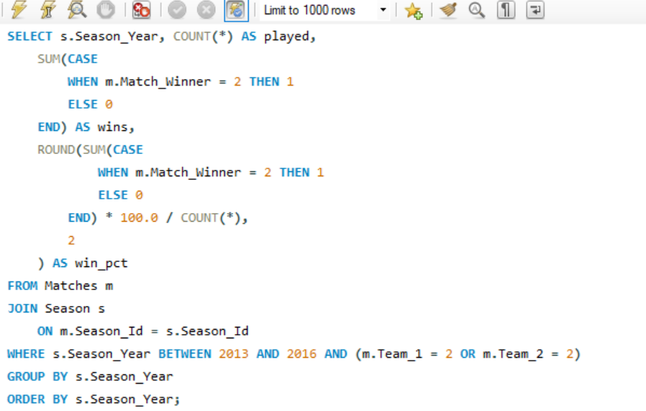

Explanation:
COUNT(*) counts RCB's matches.
SUM(CASE...) counts RCB victories.
The percentage is calculated from those two values.

Output:
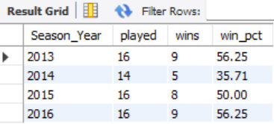

Boundary reliance — % of RCB runs from 4s and 6s
Output columns (in order): pct_runs_from_boundaries (1 column)
Row count: 1 row (single aggregate row).

Calculated total RCB runs from Batsman_Scored.
Identified balls where Runs_Scored = 4 or Runs_Scored = 6.
Calculated boundary runs as 4 + 6 = 10 for each such ball.
Divided boundary runs by total RCB runs and multiplied by 100.

SQL Query: 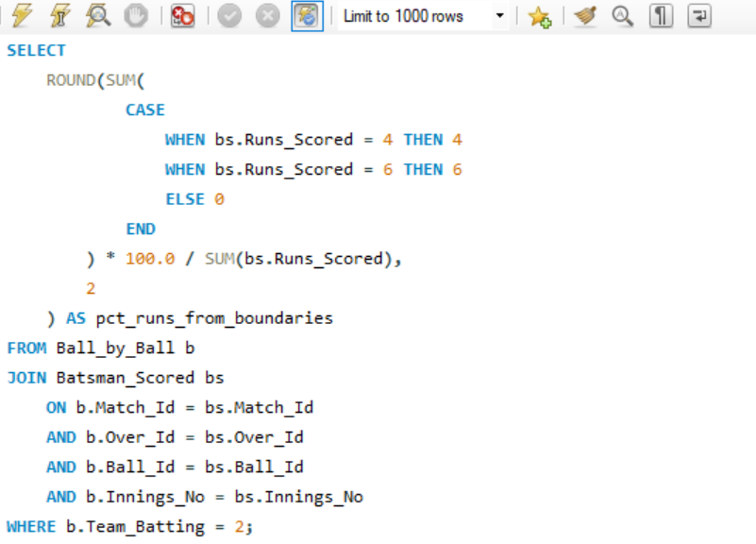

Output:
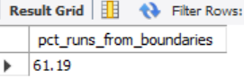

Top 5 RCB run-scorers
Output columns (in order): Player_Name, runs (2 columns)
Row count: 5 rows (LIMIT 5).

Identified balls where RCB was batting using Team_Batting = 2.
Used Striker to identify the batsman.
Sum Runs_Scored for each RCB batsman.
Joined Player to display the player's name.
Sort by total runs in descending order.
Returned the top 5 using LIMIT function.

SQL Query: 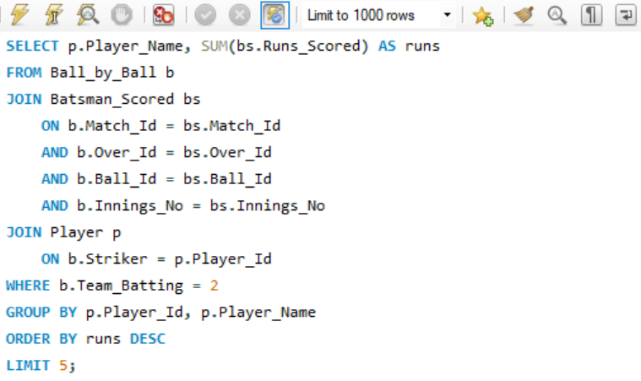
Output:
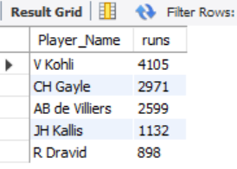

Q13 Using SQL, write a query to find out the average wickets taken by each bowler in each venue. Also, rank the gender according to the average value.
Output columns (in order): Venue_Name, Player_Name, wickets, avg_wickets, venue_rank (5 columns)
Row count: 980 rows (1 row per (bowler, venue) pair with ≥1 credited wicket).

SQL Query:
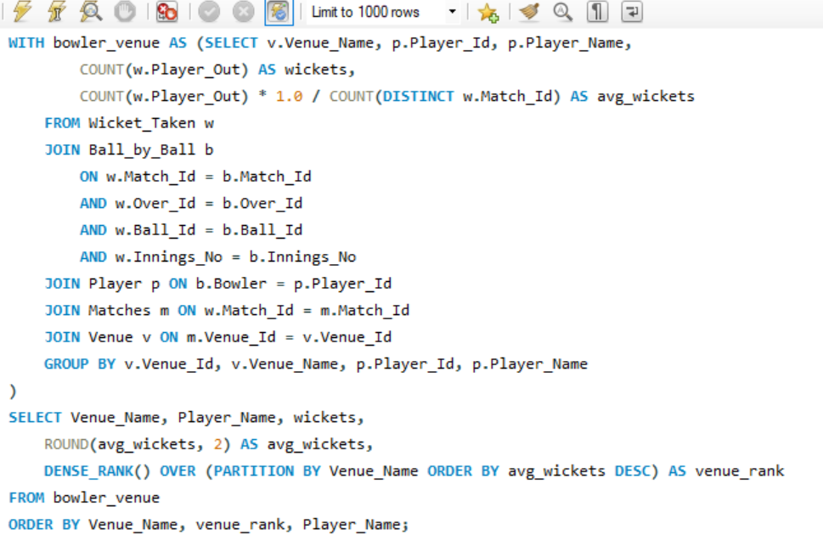
Explanation:

Used Wicket_Taken to identify credited wickets.
Joined Ball_by_Ball to identify the bowler responsible for each wicket.
Joined Player to get the bowler's name.
Joined Matches and Venue to identify the venue.
Grouped by venue + bowler.
Calculated:
wickets = total wickets taken by that bowler at that venue.
avg_wickets = average wickets per match played by that bowler at that venue.
Used DENSE_RANK() to rank bowlers within each venue according to avg_wickets.

Output: Limited output
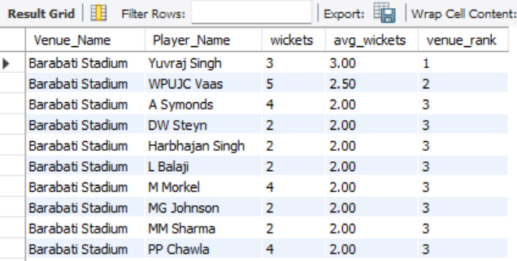

Q14 Which of the given players have consistently performed well in past seasons? (will you use any visualization to solve the problem)
Output columns (in order): Player_Name, seasons_played, avg_runs_per_season, worst_season, best_season, runs_stddev (6 columns)
Row count: 64 rows (players who batted in all 4 available seasons).

- Calculated each RCB batsman's total runs in each season.
- Kept only players who batted in all 4 seasons.
- Calculated their: seasons_played , avg_runs_per_season , worst_season , best_season , runs_stddev
- Used standard deviation of seasonal runs as the quantitative measure of consistency:
Lower runs_stddev → less variation across seasons.
Higher runs_stddev → greater variation.
- SUM(bs.Runs_Scored) - calculates the runs scored by each RCB batsman in each season.
- HAVING COUNT(*) = 4 - ensures that only players who have batting records in all four seasons (2013– 2016) are retained.
- avg_runs_per_season - The average of the player's four seasonal run totals.
- worst_season - The season in which the player had their lowest seasonal runs.
- best_season - The season in which the player had their highest seasonal runs.
- If there is a tie, the query returns the earliest season among the tied seasons.
- STDDEV_POP(runs) - calculates the population standard deviation of the player's four seasonal run totals.
SQL Query: 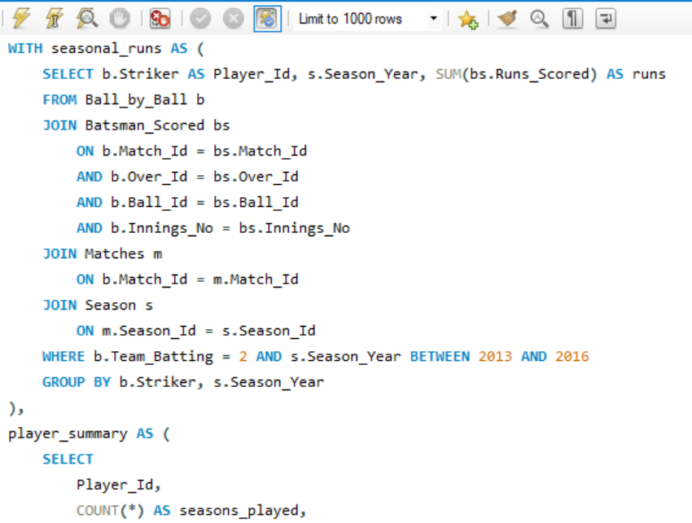
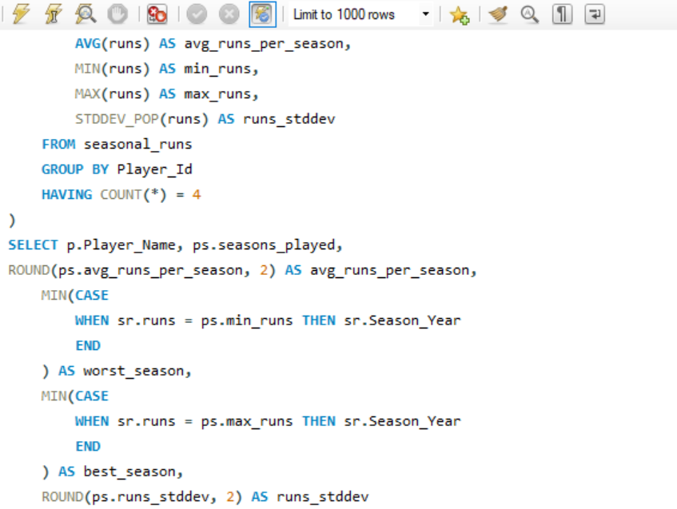
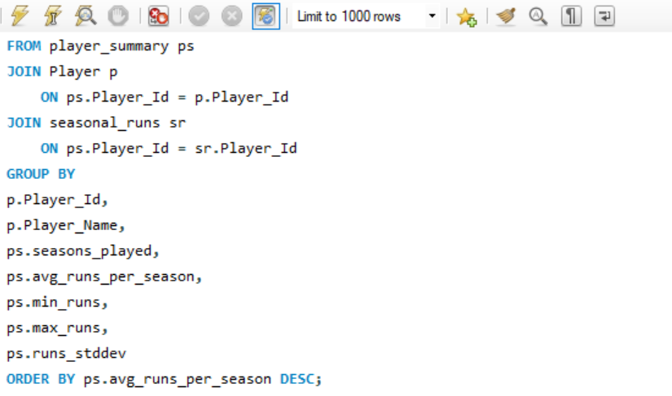
Output: Limited output, total row count - 64 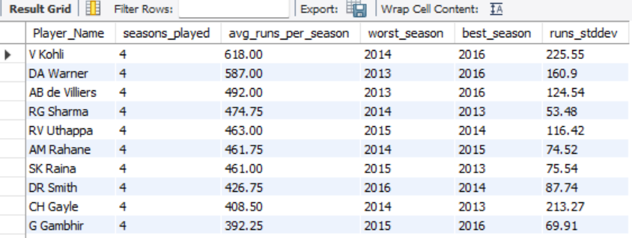

Q15 Are there players whose performance is more suited to specific venues or conditions? (how would you present this using charts?)
Output columns (in order): Player_Name, Venue_Name, runs, balls, strike_rate (5 columns)
Row count: 25 rows (LIMIT 25; comfortably enough player/venue pairs clear the 60-ball minimum).

Used Ball_by_Ball to identify the striker and venue.
Used Batsman_Scored to calculate runs.
Used Matches and Venue to identify the venue.
Grouped the data by player + venue.
Calculated:
runs = total runs scored by the player at that venue.
balls = number of deliveries faced.
strike_rate = runs / balls × 100.
Sorted by strike rate and returned the top 25 player–venue combinations.

SQL Query: 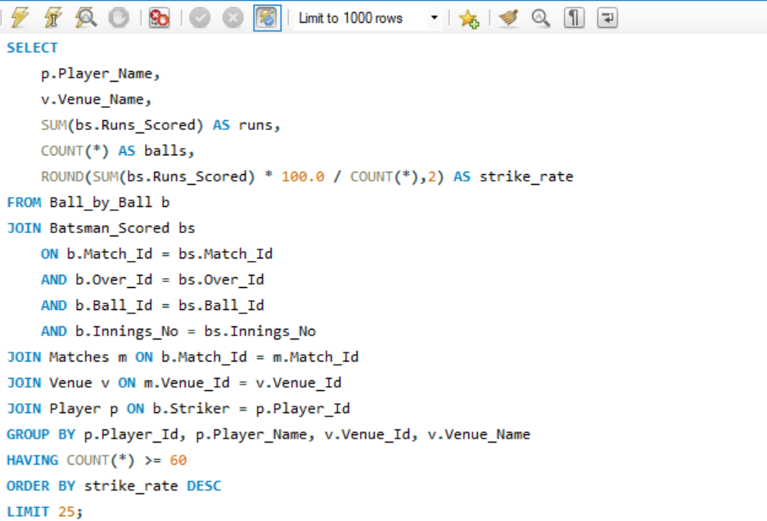
Output:
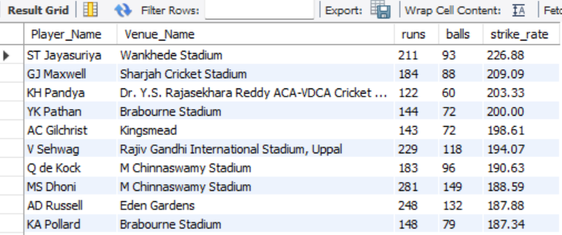

Data Visualization
To present the results, I used a horizontal bar chart titled “Top Player–Venue Performances by Strike Rate.”
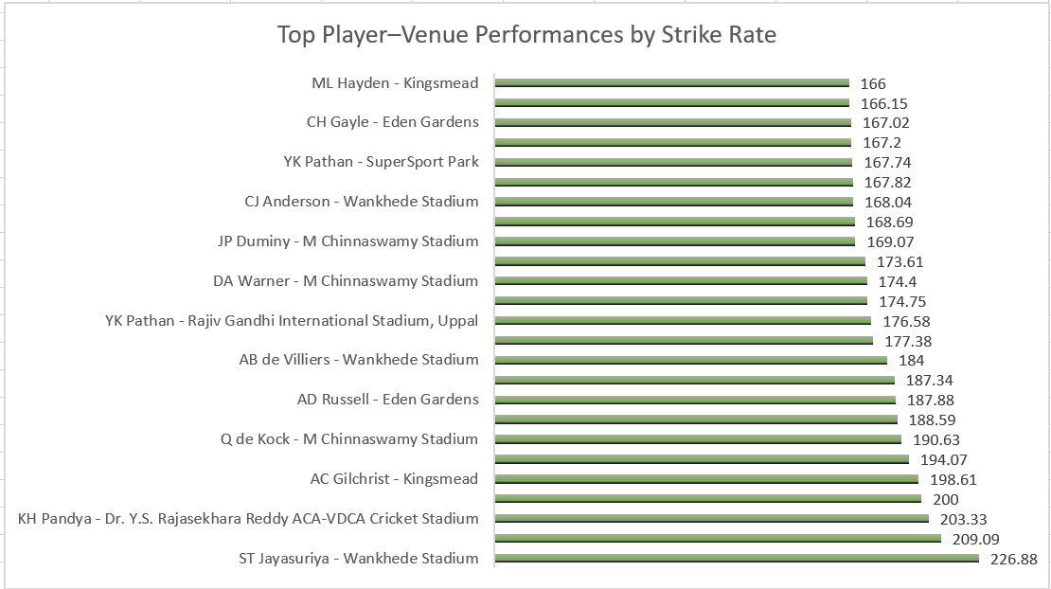
- The Y-axis shows the player–venue combinations.
- The X-axis represents the strike rate.
- Each bar represents the strike rate achieved by a player at a particular venue.
- The strike-rate value is displayed at the end of each bar for easy comparison.
- The chart includes the top 25 player–venue combinations identified by the SQL query, with a minimum of 60 balls faced.
This chart makes it easy to identify cases where a player's batting performance was particularly strong at a specific venue. For example, ST Jayasuriya at Wankhede Stadium recorded the highest strike rate in the output at 226.88, followed by GJ Maxwell at Sharjah Cricket Stadium (209.09) and KH Pandya at Dr. Y.S. Rajasekhara Reddy ACA-VDCA Cricket Stadium (203.33).
The visualization therefore provides a clear comparison of player performance across specific venues rather than looking at overall player performance alone.

Subjective Questions
Q1 How does the toss decision affect the result of the match? (which visualizations could be used to present your answer better) And is the impact limited to only specific venues?
I analyzed the relationship between the toss decision (bat or field) and whether the toss winner eventually won the match.
I used two levels of analysis:
- Overall toss impact — compare win percentage for teams choosing to bat vs field.
- Venue-wise toss impact — check whether this relationship changes from venue to venue.
Overall Toss Impact
SQL Query: 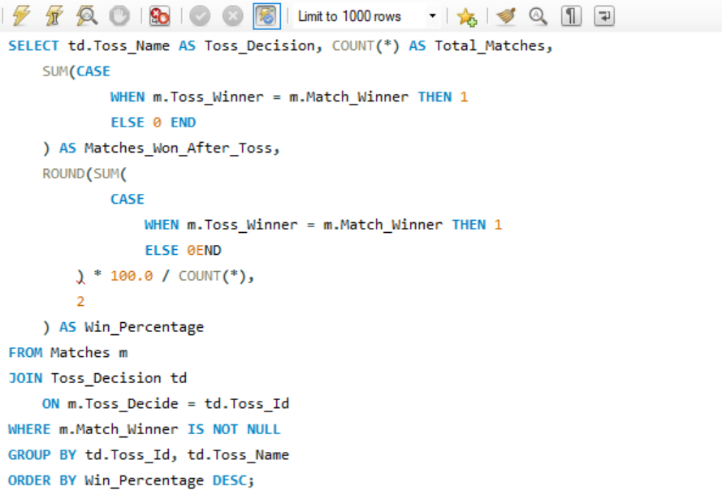
Output:
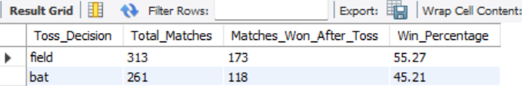
Explanation:
- Teams choosing to field after winning the toss won 55.27% of those matches.
- Teams choosing to bat after winning the toss won 45.21%.
- Therefore, in this IPL dataset, the toss winner's match-winning percentage was higher when the decision was to field.
- The difference is 10.06 percentage points.
Venue-wise toss impact
SQL Query: 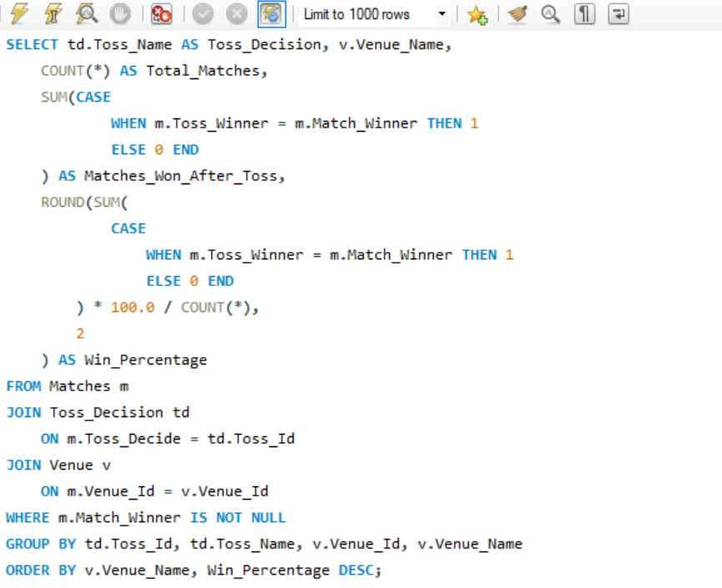
Output: Limited output, the venue output shows that the effect varies considerably by venue.
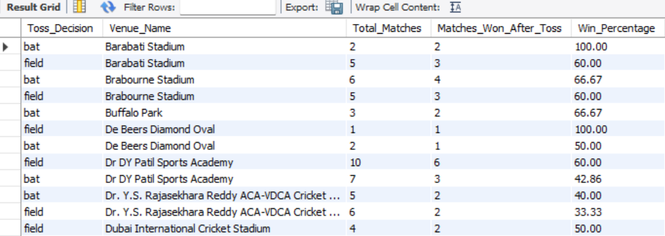
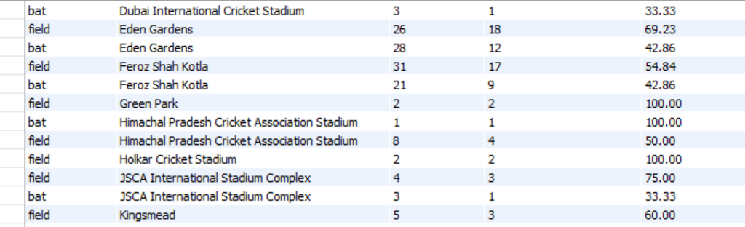
There are also venues where one decision has 100% or 0%, but these often come from very small numbers of matches. For example, some venues have only 1–3 matches for a particular toss decision, so those percentages should be interpreted cautiously.
Does the impact occur only at specific venues?
No. The difference is not limited to one or two venues.
Across venues, there are examples where:
- Fielding has a higher toss-winner success rate, such as Eden Gardens, Sawai Mansingh Stadium and Rajiv Gandhi International Stadium.
- Batting has a higher success rate, such as MA Chidambaram Stadium, Chepauk, Barabati Stadium and Newlands.
- Some venues show almost no difference, such as Wankhede Stadium, Kingsmead and Sardar Patel Stadium.
So the venue-level results indicate that the relationship between toss decision and match outcome changes depending on the venue.

Dashboard / Visualization Explanation
Approach:
We analyzed whether the toss decision was associated with the match result by comparing the percentage of toss winners who also won the match.
Overall Analysis:
We grouped the matches based on the toss decision — Field and Bat — and calculated the percentage of toss winners who went on to win the match. The overall analysis showed 55.27% for Field and 45.21% for Bat.
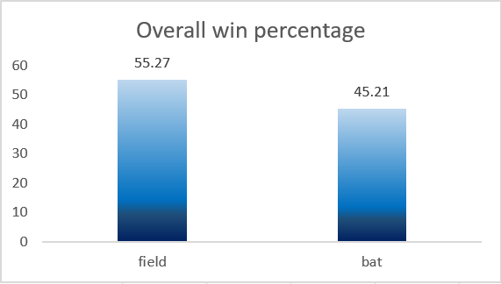
Venue-wise Analysis:
To check whether this pattern was consistent across venues, we further grouped the data by Venue and Toss Decision and calculated the corresponding win percentage.
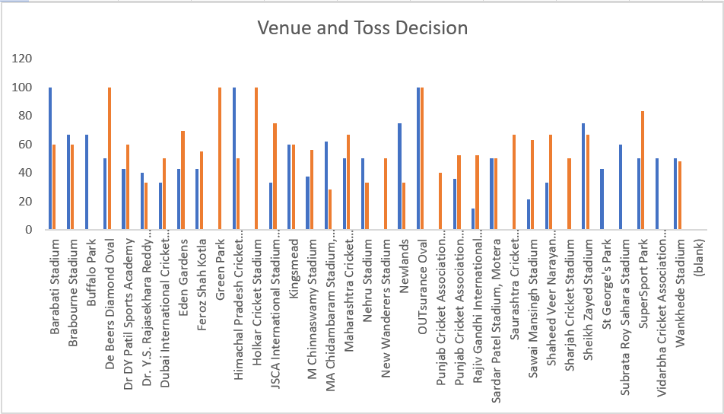

Dashboard Creation:
- Created a column chart to compare the overall win percentage for Field vs Bat.
- Created a clustered bar/column chart to compare toss impact across different venues.
- Used Win Percentage as the primary metric, while retaining Total Matches to provide context for the results.
Conclusion:
In the dataset, choosing to field after winning the toss is associated with a higher match-winning percentage overall (55.27%) than choosing to bat (45.21%).
However, the venue-wise results show that this pattern is not consistent across all venues. At some venues fielding has a higher success rate, while at others batting has a higher success rate or the two are equal.
Therefore, venue appears to be an important factor when examining the relationship between toss decision and match result, rather than the overall toss-decision percentage applying uniformly to every venue.

Q2 Suggest some of the players who would be best fit for the team.
Evaluated player performance during 2013–2016 using two key performance measures:
- Strike Rate — to identify effective batting performers.
- Total Wickets — to identify effective bowling performers.
This provides a data-driven basis for identifying players who can contribute strongly to the team.
Batting Performance
SQL Query:
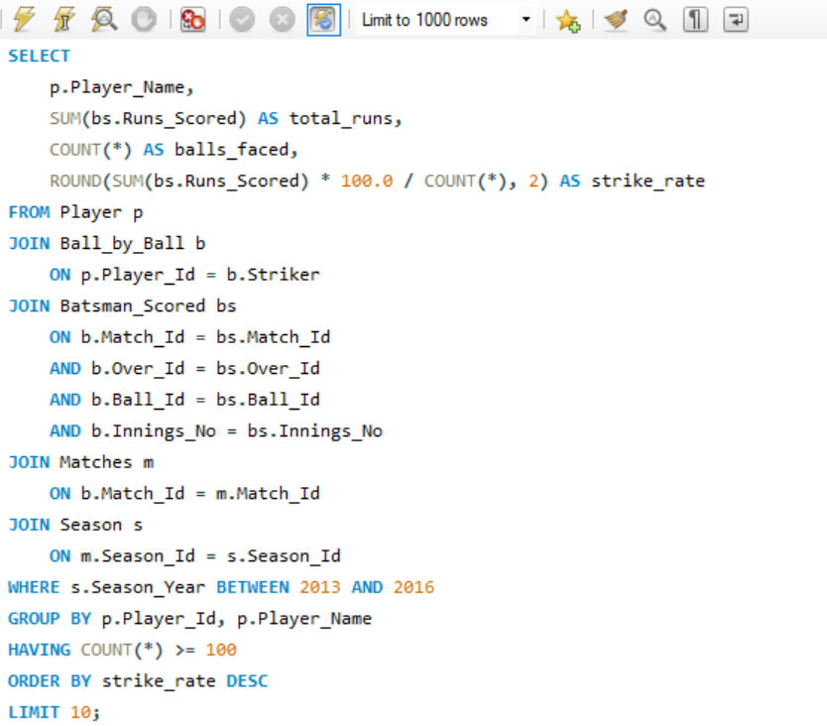
Output:
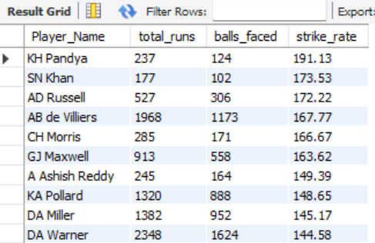
Explanation:
- Player is joined with Ball_by_Ball using the Striker column to identify the batsman.
- Batsman_Scored is joined to obtain the runs scored on each delivery.
- Matches and Season are joined so that we can restrict the analysis to 2013–2016.
- SUM(bs.Runs_Scored) calculates each player's total runs.
- COUNT(*) calculates the number of balls faced.
- Strike rate is calculated as:
Strike Rate = (Total Runs / Balls Faced) × 100
- HAVING COUNT(*) >= 100 removes players with very small batting samples.
- The results are ordered by strike rate in descending order.
- LIMIT 10 returns the top 10 players.
Bowling Performance
SQL Query:
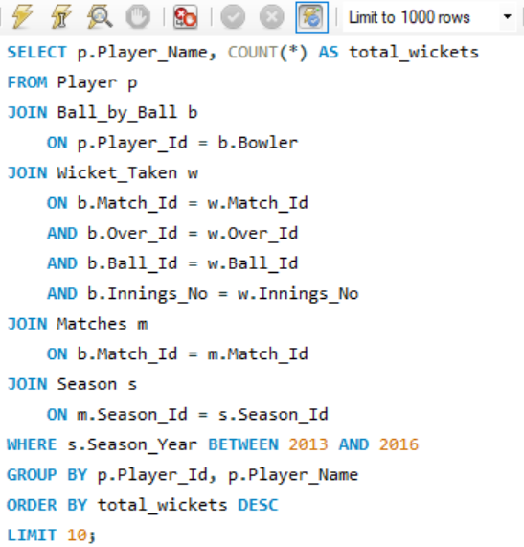
Output:
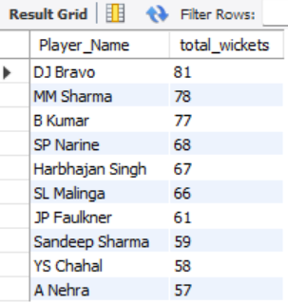
Explanation:
- Player is joined with Ball_by_Ball using the Bowler column to identify the actual bowler.
- Wicket_Taken is joined using the match, over, ball and innings identifiers so that wickets are linked to the corresponding delivery.
- Matches and Season restrict the analysis to 2013–2016.
- COUNT(*) calculates the total wickets associated with each bowler.
- Players are grouped individually using Player_Id and Player_Name.
- The results are sorted from the highest to lowest wicket count.
- LIMIT 10 returns the top 10 wicket-taking players.

Dashboard / Visualization
Created two horizontal bar charts because player names are categorical and can be lengthy.
Chart 1 — Top Players by Strike Rate (2013–2016)- The chart compares the strike rate of the top 10 batting performers.
The highest values in our output were:
- KH Pandya — 191.13
- SN Khan — 173.53
- AD Russell — 172.22
- AB de Villiers — 167.77
- CH Morris — 166.67
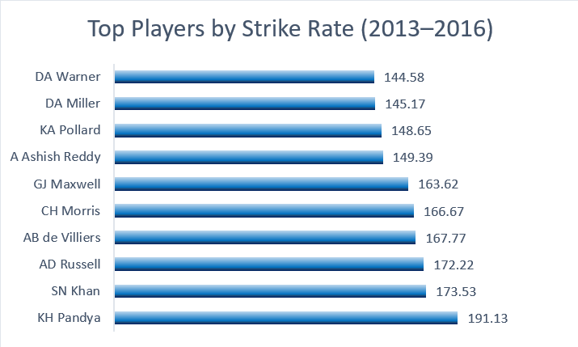
Chart 2 — Top Players by Wickets (2013–2016) - The chart compares the total wickets of the top 10 wicket-taking players.
The leading performers were:
- DJ Bravo — 81
- MM Sharma — 78
- B Kumar — 77
- SP Narine — 68
- Harbhajan Singh — 67
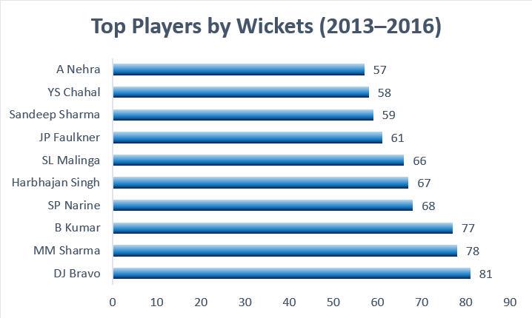
Key Findings:
The batting analysis identifies KH Pandya, SN Khan and AD Russell among the highest strike-rate performers in the selected period.
The bowling analysis identifies DJ Bravo, MM Sharma and B Kumar as the leading wicket-takers.
These results provide separate indicators for batting strength and bowling strength, which can be used to identify potential players for team selection.

Conclusion:
Based on the analyzed performance metrics, players such as KH Pandya, SN Khan, AD Russell provide strong batting impact, while DJ Bravo, MM Sharma and B Kumar provide strong bowling contributions. The analysis therefore provides a data-driven shortlist of potential players based on their performance during 2013–2016.

Q3 What are some of the parameters that should be focused on while selecting the players?
Identified the key performance parameters that can be used to evaluate players and select a balanced team.
Important parameters:
- Total Runs – overall batting contribution.
- Strike Rate – scoring efficiency.
- Average Runs – consistency in batting performance.
- Total Wickets – bowling contribution.
- Average Wickets – consistency in taking wickets.
- Consistency across seasons – whether performance is maintained over multiple seasons.
- Venue Performance – ability to perform under different venue conditions.
- Bowling Style – useful for maintaining variety and balance in the bowling attack.
- Age/Experience – can be considered along with performance data.
Conclusion:
Player selection should not be based on a single metric. A combination of batting performance, bowling performance, consistency, venue performance and overall team balance should be considered when selecting players.

Q4 Which players offer versatility in their skills and can contribute effectively with both bat and ball? (can you visualize the data for the same)
Some players are not just good at one skill — they are valuable all-rounders, meaning they contribute significantly with both bat and ball.
To identify such players, I will calculate:
- Total Runs scored as a batsman
- Total Wickets taken as a bowler
- Filter players with at least 200 runs and 15 wickets
The thresholds of 200 runs and 15 wickets are used to remove players with only limited contributions and focus on players who have made a meaningful contribution in both areas.
SQL Query: 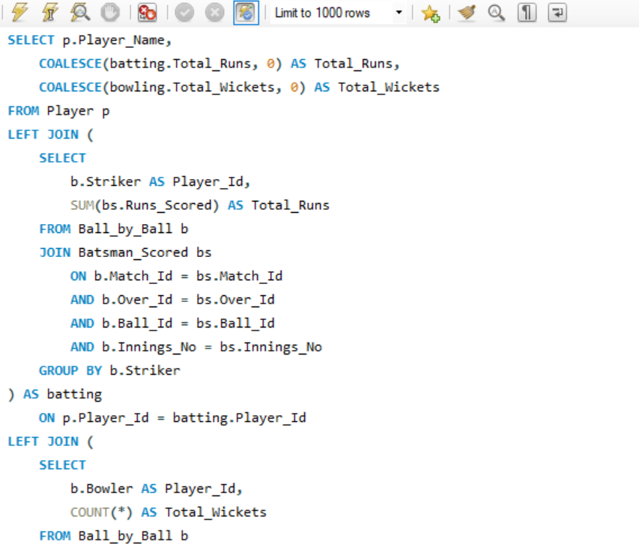
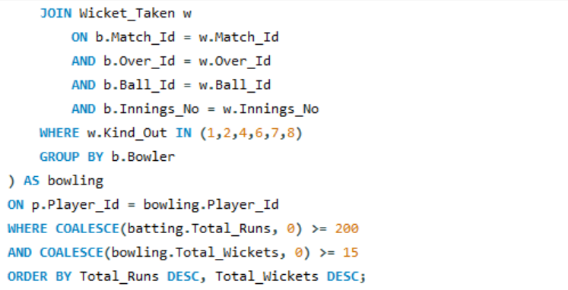
Explanation:
- The batting subquery joins Ball_by_Ball with Batsman_Scored and calculates total runs for each player.
- The bowling subquery identifies each player's wickets using Ball_by_Ball.Bowler.
- Only bowler-credited dismissals are counted.
- Both results are joined with the Player table.
- Players are filtered to have:
at least 200 runs
at least 15 wickets
- The result is sorted by total runs and then wickets.

Output: Limited output
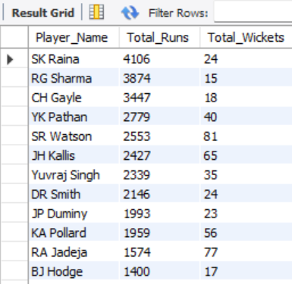

Data Visualization
To visualize the all-rounder performance, I used a dual-axis combo chart titled “All-Rounder Players – Total Runs & Total Wickets.”
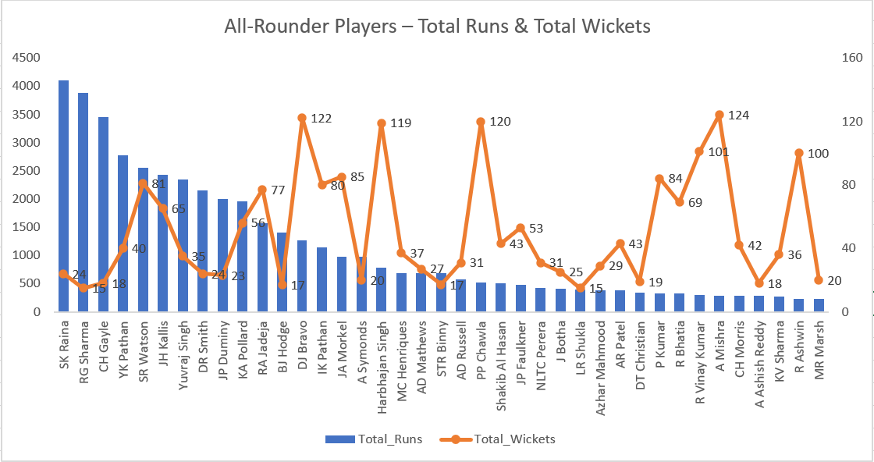
- The blue columns represent the total runs scored by each player.
- The orange line represents the total wickets taken.
- Total runs are shown on the primary Y-axis, while total wickets are shown on the secondary Y-axis, since the scales of the two metrics are very different.
- The player names are shown on the X-axis.
This visualization makes it easier to compare batting and bowling contributions together and identify players who have made a significant contribution in both areas.
Analysis / Key Findings
The analysis shows that the selected players have made meaningful contributions with both bat and ball based on the minimum thresholds of 200 runs and 15 wickets.
- SK Raina has the highest batting contribution among the selected players, with more than 4,000 runs.
- RG Sharma and CH Gayle also have very high total run contributions.
- DJ Bravo, JP Faulkner, Harbhajan Singh and R Ashwin stand out for their strong wicket contributions.
- SR Watson, JH Kallis, RA Jadeja and AD Russell are particularly notable because they have contributed significantly in both batting and bowling.
- The chart also shows that being an all-rounder does not necessarily mean having the highest value in both metrics. Some players are more batting-oriented, while others contribute more strongly with the ball.
Overall, the visualization helps identify players who can provide balance and flexibility to a T20 team by contributing in both departments.
Conclusion
Based on the analysis, players such as SR Watson, JH Kallis, RA Jadeja and AD Russell stand out as valuable all-round contributors because they have made meaningful contributions with both bat and ball. At the same time, players such as DJ Bravo and JP Faulkner show particularly strong bowling contributions along with sufficient batting output to meet the selection criteria.
Therefore, considering all-rounders can help a team build a more balanced squad, as these players provide additional options in both batting and bowling and can contribute to the team in multiple situations.

Q5 Are there players whose presence positively influences the morale and performance of the team? (justify your answer using visualization)
To evaluate this, I analyzed RCB's win percentage in matches where individual players participated.
Since the database does not contain a direct measure of player morale, I used team win percentage as a performance-based indicator. Then compared each player's win percentage with RCB's overall win percentage.
I used a minimum of 10 matches played to avoid drawing conclusions from players with very few appearances.
Player-wise Performance
SQL Query:
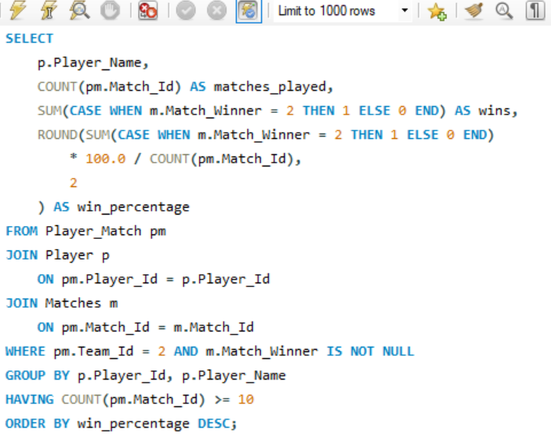
Explanation:
Player_Match is used to identify players who actually participated in RCB matches.
pm.Team_Id = 2 restricts the analysis to RCB.
Player is joined to obtain the player's name.
Matches is joined to obtain the result of each match.
COUNT(pm.Match_Id) calculates the number of matches in which the player participated.
The CASE expression counts matches where Match_Winner = 2, meaning RCB won.
win_percentage is calculated as: Wins ÷ Matches Played × 100
HAVING COUNT(pm.Match_Id) >= 10 ensures that only players with at least 10 appearances are considered.
Finally, the players are sorted by win percentage from highest to lowest.

Output: Limited output
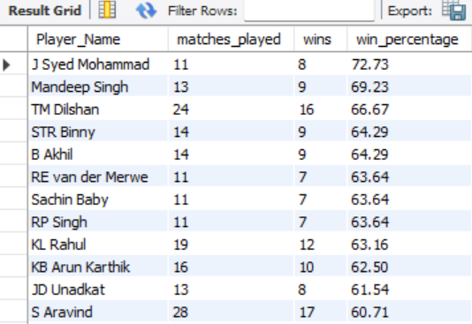

Overall RCB Benchmark
SQL Query: 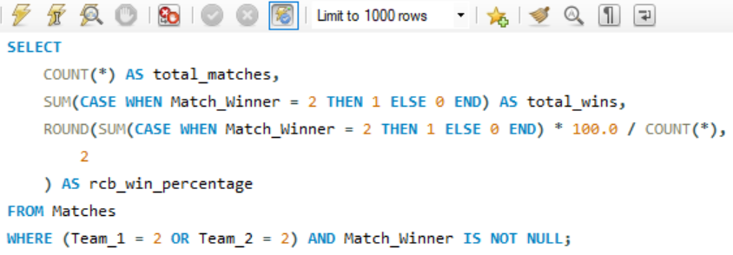
Explanation:
The Matches table contains the teams involved and the match winner.
Team_1 = 2 OR Team_2 = 2 selects all matches in which RCB participated.
Match_Winner IS NOT NULL ensures that only matches with a recorded result are included.
COUNT(*) gives the total number of RCB matches.
The CASE expression counts the matches won by RCB.
The win percentage is calculated as:

RCB Wins ÷ Total RCB Matches × 100
ROUND(..., 2) displays the result to two decimal places.
Output:
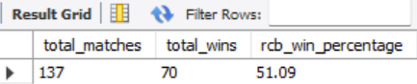
Therefore, 51.09% is our benchmark for evaluating the player-level results.
Data Visualization
Created a horizontal bar chart using the Top 10 players according to their win percentage.
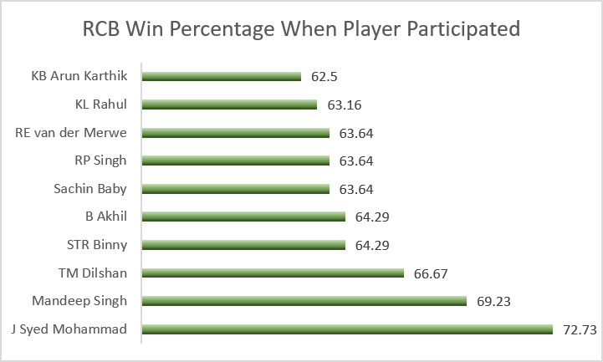
Chart configuration
Chart Type: Horizontal Clustered Bar Chart
Title:
RCB Win Percentage When Player Participated
X-axis:
Win Percentage (%)
Y-axis:
Player Name
The chart shows the players' win percentages clearly and makes it easy to compare them with the 51.09% overall RCB win rate.
The results show that RCB had a better win percentage in matches where these players participated.
However, this does not necessarily mean that the players alone were responsible for the wins. Factors such as the opponent, venue, season and overall team performance can also affect the result.
Also, players have played different numbers of matches, so their win percentages should be considered along with their matches played.
Conclusion
The analysis shows that several players were associated with better RCB results. J Syed Mohammad, Mandeep Singh and TM Dilshan had particularly high win percentages when they played for RCB, compared with the team's overall win rate of 51.09%. This suggests that their presence was linked with stronger team performance during the matches analyzed. However, the data does not directly measure player morale, so the finding is based on match performance rather than morale itself.

Q6 What would you suggest to RCB before going to the mega auction?
Before the mega auction, RCB should focus on building a balanced and consistent squad. The selection should not depend on one statistic alone. Batting performance, bowling performance, consistency, versatility and performance in different conditions should all be considered.
Suggestions for RCB
- Strengthen the bowling attack
RCB should give priority to reliable wicket-taking bowlers. A strong bowling unit can reduce the pressure on the batting lineup and help defend competitive totals.
- Maintain a strong batting core
RCB should retain dependable run scorers along with a few high strike-rate players who can increase the scoring rate when required.
- Add quality all-rounders
Players who can contribute with both bat and ball can give the team more flexibility and help maintain a good balance between the two departments.
- Give importance to consistency
RCB should look at players who have performed well over multiple seasons rather than selecting someone based only on one particularly good season.
- Consider venue performance
Since player performance can vary across venues, RCB should consider players who can adapt to different playing conditions and not depend only on specialists for one particular type of pitch.
- Use team-performance indicators as an additional factor
Our analysis of player participation and RCB's win percentage can also be used as one of the supporting factors while making auction decisions.
Conclusion
Before the mega auction, RCB should focus on creating a balanced squad rather than relying heavily on a few star players. The main priorities should be a strong bowling attack, dependable batsmen, quality all-rounders and players who have shown consistency across seasons and conditions. A combination of these factors would give RCB better squad depth and more flexibility during matches.

Q7 What do you think could be the factors contributing to the high-scoring matches and the impact on viewership and team strategies
To understand high-scoring matches, I analysed the data in two parts.
First, I identified the top 10 highest-scoring matches based on total runs and examined the contribution of batting runs, extra runs, fours and sixes.
Second, I analysed average runs per ball across venues to understand whether scoring intensity varies from one venue to another.
This approach helps identify factors that are directly visible in the dataset without making assumptions about pitch conditions, boundary dimensions, weather or other factors that are not available in the SQL database.

Top 10 High-Scoring Matches
SQL Query:
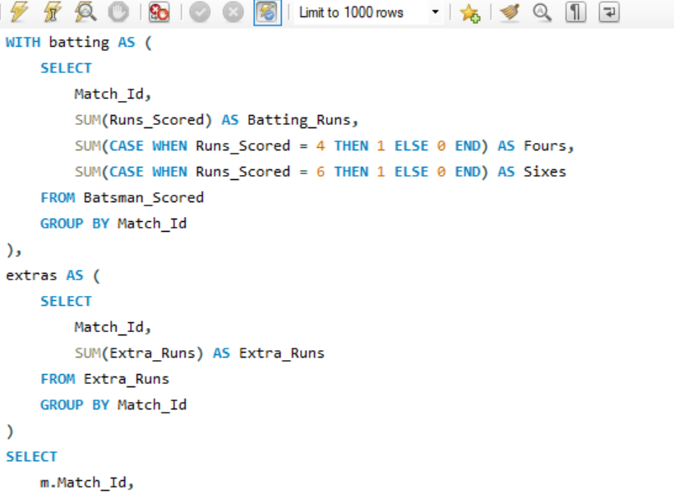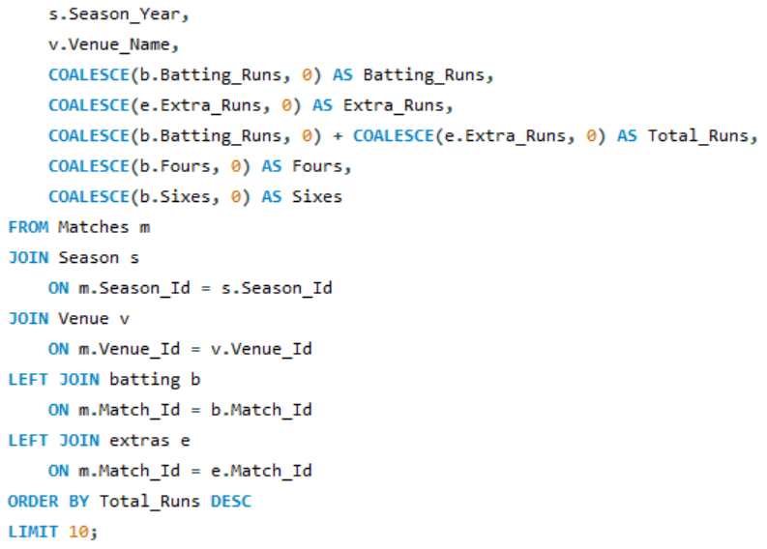
Explanation:
- The batting CTE uses the Batsman_Scored table to calculate the total batting runs for each match.
- It also counts the number of fours and sixes using CASE statements.
- The extras CTE calculates the total extra runs for each match from the Extra_Runs table.
- These two results are joined with the Matches table using Match_Id.
- The Season table is joined to identify the season year, while the Venue table provides the venue name.
- COALESCE is used so that a missing batting or extra-run value is treated as zero.
- Batting_Runs + Extra_Runs gives the Total_Runs for each match.
- The results are sorted in descending order of total runs, and LIMIT 10 returns the 10 highest-scoring matches.

Output: 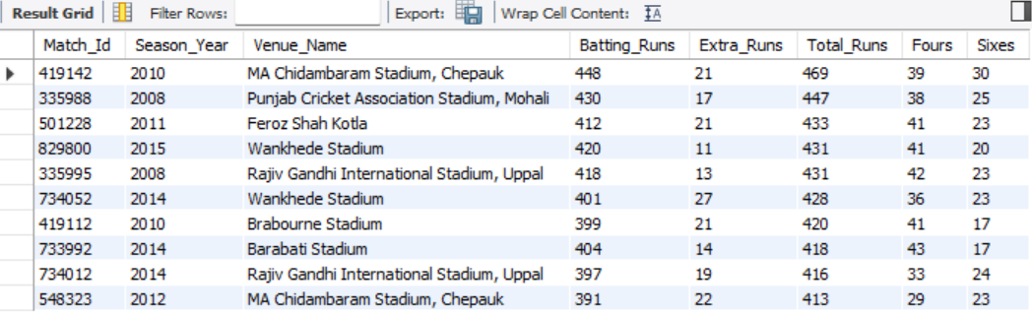

Data Visualization
1. Top 10 Highest-Scoring IPL Matches
I used a clustered column chart titled:
Top 10 Highest-Scoring IPL Matches
- X-axis: Match_Id
- Y-axis: Total_Runs
- Data labels: Total runs
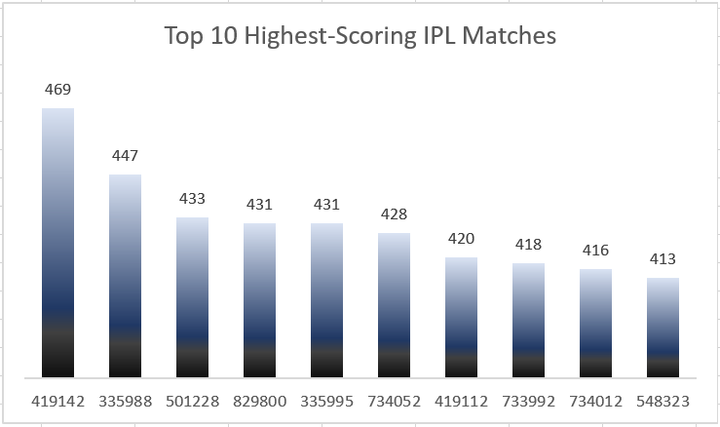
The chart shows that the highest-scoring match recorded 469 runs, followed by matches with 447, 433, 431 and 431 runs. All ten matches in the analysis crossed 400 total runs.
The high total scores are accompanied by substantial boundary scoring. For example, the highest-scoring match had 39 fours and 30 sixes, while several other matches also recorded a high number of fours and sixes.

Venue Scoring Analysis
SQL Query: 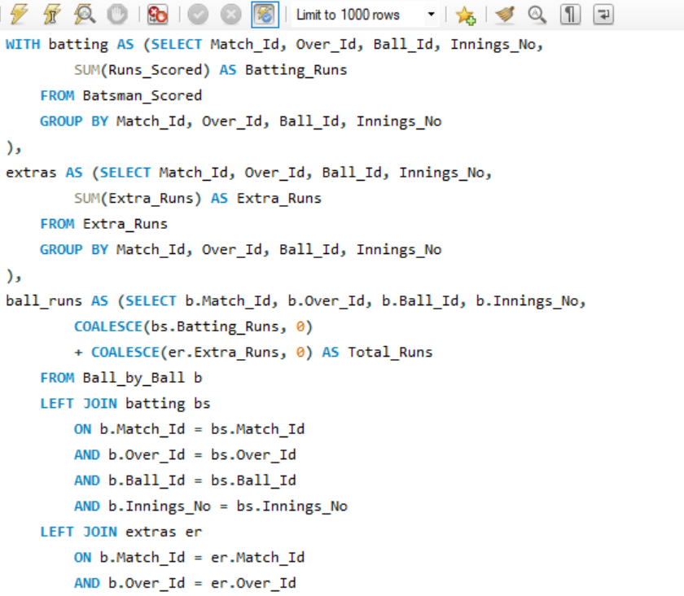 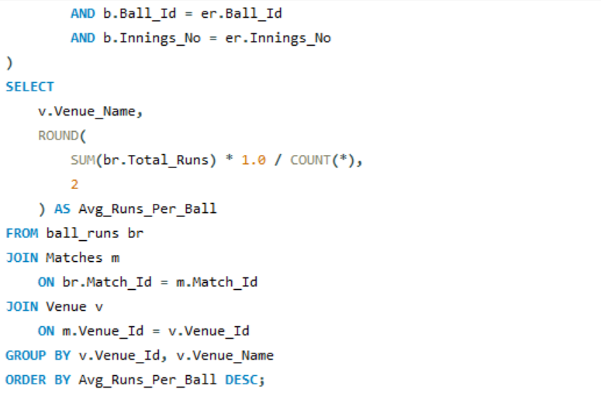
Explanation:
- The batting CTE calculates the batting runs recorded on each individual delivery.
- The extras CTE calculates the extra runs recorded on each delivery.
- The ball_runs CTE combines batting runs and extra runs to calculate the total runs scored on each delivery.
- Ball_by_Ball is used as the base because it provides the individual delivery records needed to calculate the number of balls.
- The Matches table is joined using Match_Id to connect each delivery to its match.
- The Venue table is then joined to identify the venue where the match was played.
- The query calculates Average Runs Per Ball as total runs divided by the number of recorded deliveries.
- Finally, the venues are grouped and sorted from the highest to lowest average runs per ball.

Data Visualization

2. Average Runs Per Ball by Venue
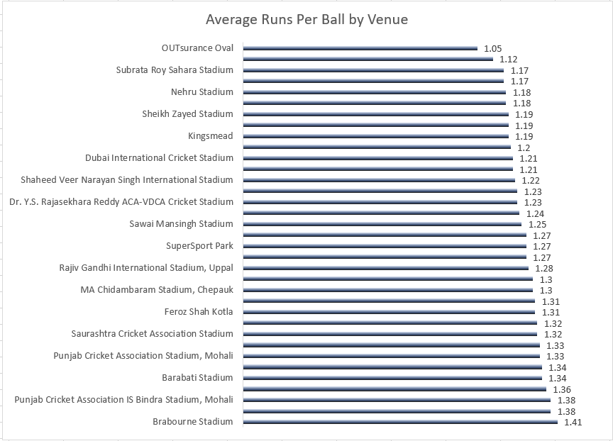
I used a horizontal bar chart titled:
Average Runs Per Ball by Venue
- Y-axis: Venue_Name
- X-axis: Avg_Runs_Per_Ball
- Data labels: Average runs per ball
- Venues sorted from highest to lowest
The highest value was recorded at Brabourne Stadium with 1.41 runs per ball, followed by Punjab Cricket Association IS Bindra Stadium, Mohali and M Chinnaswamy Stadium at 1.38.
At the lower end, OUTsurance Oval recorded 1.05 runs per ball, while Buffalo Park recorded 1.12.

Key Findings:
From the first analysis, I found that the highest-scoring matches had very high batting scores along with a large number of fours and sixes. All 10 matches in the analysis crossed 400 total runs, with the highest scoring match recording 469 runs.
The venue analysis also shows that scoring rates are different across venues. Brabourne Stadium had the highest average of 1.41 runs per ball, while OUTsurance Oval had the lowest among the venues shown, at 1.05 runs per ball.
So, based on the data, two things stand out: high boundary scoring in individual matches and differences in scoring intensity across venues.
However, the dataset does not contain information about pitch conditions, boundary size or weather. Therefore, I cannot say that these factors are responsible for the differences in scoring.
Impact on Viewership:
The SQL dataset does not contain any viewership data, so I cannot measure whether high-scoring matches actually received higher viewership.
From a general business perspective, matches with more runs, fours and sixes may be more interesting to viewers. However, this is only a possible implication and would need actual viewership data to confirm.
Impact on Team Strategies:
The analysis can still be useful for team planning.
- Venue planning: Teams can look at the historical scoring rate of a venue while preparing their match strategy.
- Batting: Since boundaries are an important part of the high-scoring matches analysed, teams can consider players who can score boundaries consistently.
- Bowling: At venues with higher scoring rates, restricting boundaries and controlling the scoring rate becomes more important.
- Player selection: Venue performance can be one of the factors considered while selecting the playing XI, along with individual player performance and overall team balance.
Conclusion
Overall, my analysis shows that the highest-scoring matches were mainly associated with high batting output and a large number of boundaries. I also found that the average scoring rate varies across venues.
These findings can help teams consider venue conditions, batting combinations and bowling strategies while planning for different matches.

Q8 Analyze the impact of home-ground advantage on team performance and identify strategies to maximize this advantage for RCB.
I analyzed RCB's match performance across different venues using the number of matches played, wins, losses, and win percentage. The objective was to determine whether RCB has a meaningful home-ground advantage and identify strategies that could help maximize it.
SQL Query: 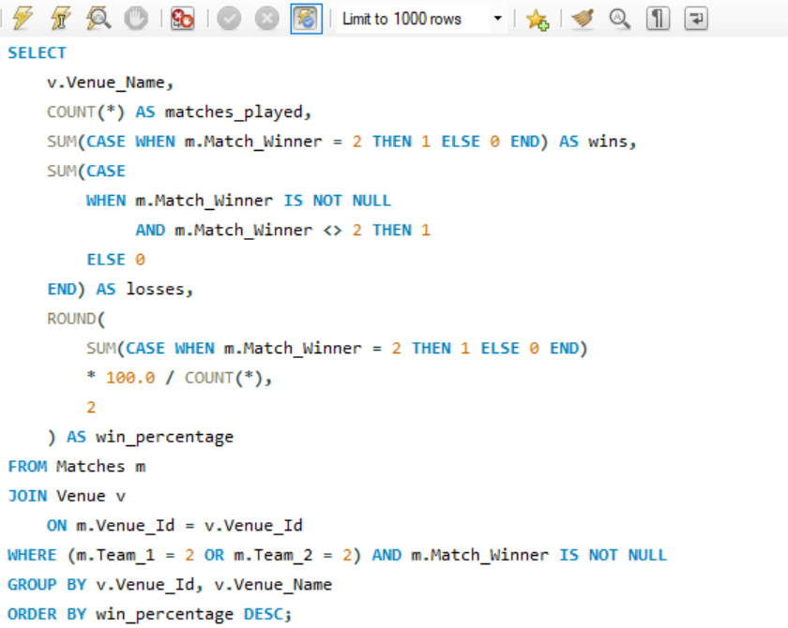
Explanation:
Matches is joined with Venue to identify the venue.
Team_1 = 2 OR Team_2 = 2 selects only RCB matches.
SUM(CASE...) calculates RCB's wins and losses.
win_percentage calculates the percentage of matches won at each venue.
Results are ordered from the highest to the lowest win percentage.

Output: Limited output
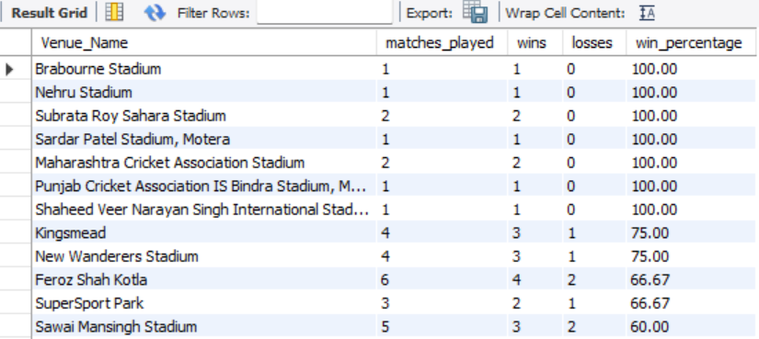

Data Visualization
Chart: Horizontal Bar Chart
Title: RCB Win Percentage by Venue
The chart compares RCB's win percentage across different venues.
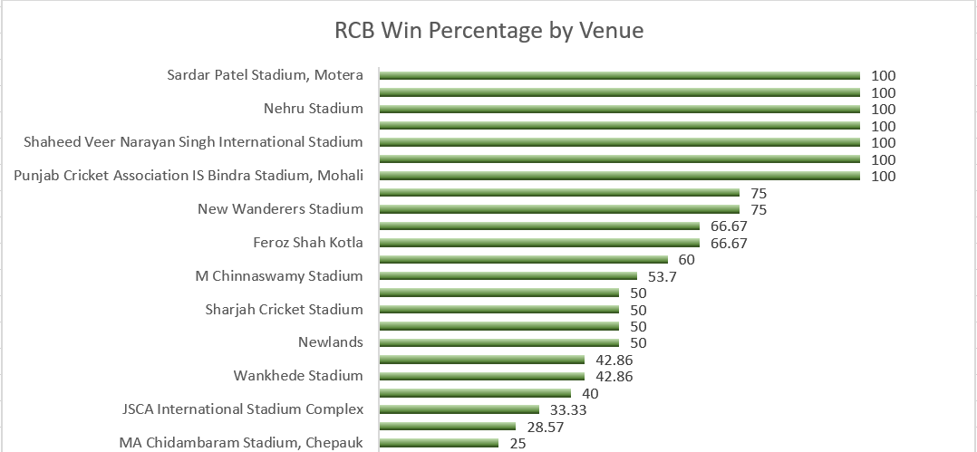

The percentage should be considered together with the number of matches played. For example, some venues show 100% win percentage but have very few matches, so they are not as reliable for judging RCB's overall venue advantage.
Key Findings
- M Chinnaswamy Stadium is RCB's most important venue in the dataset, with 54 matches.
- RCB won 29 and lost 25 matches there.
- This gives RCB a 53.70% win percentage at the venue.
- Although this is a positive record, 53.70% is not a very strong home-ground advantage. RCB has won only slightly more than half of its matches there.
- RCB had higher win percentages at some other venues, such as Feroz Shah Kotla (66.67%) and Sawai Mansingh Stadium (60%), but these venues had considerably fewer matches.
- RCB's win percentage was 42.86% at Wankhede Stadium and 42.86% at Eden Gardens.
- The lowest percentage among the displayed venues was 25% at MA Chidambaram Stadium.
Strategies to Maximize Home-Ground Advantage
RCB can improve its home performance by:
- Selecting players suited to Chinnaswamy conditions, particularly batsmen who can score quickly.
- Strengthening death-over bowling, where matches can change quickly.
- Developing venue-specific bowling plans for different types of opposition batsmen.
- Using previous venue performance to support player selection and match strategy.
- Focusing on consistency, because the current 53.70% record shows that the home advantage has not been strong enough to consistently convert home matches into wins.
Conclusion
The analysis shows that RCB does have a positive record at M Chinnaswamy Stadium, but the home-ground advantage is not particularly strong. With 29 wins and 25 losses from 54 matches, the 53.70% win rate is only slightly above 50%.
Therefore, RCB should not rely on home conditions alone. A venue-specific strategy, strong batting lineup, reliable death bowling, and consistent player selection could help convert the existing home advantage into a stronger and more consistent winning record.

Q9 Come up with a visual and analytical analysis of RCB's past season's performance and potential reasons for them not winning a trophy.
I analysed RCB's performance for the four seasons from 2013 to 2016. I compared the team's matches played, wins, losses, win percentage, total runs scored and wickets taken.
The objective was to identify how consistent RCB's performance was across these seasons and whether there were any noticeable weaknesses in their batting, bowling or overall team performance.
SQL Query:
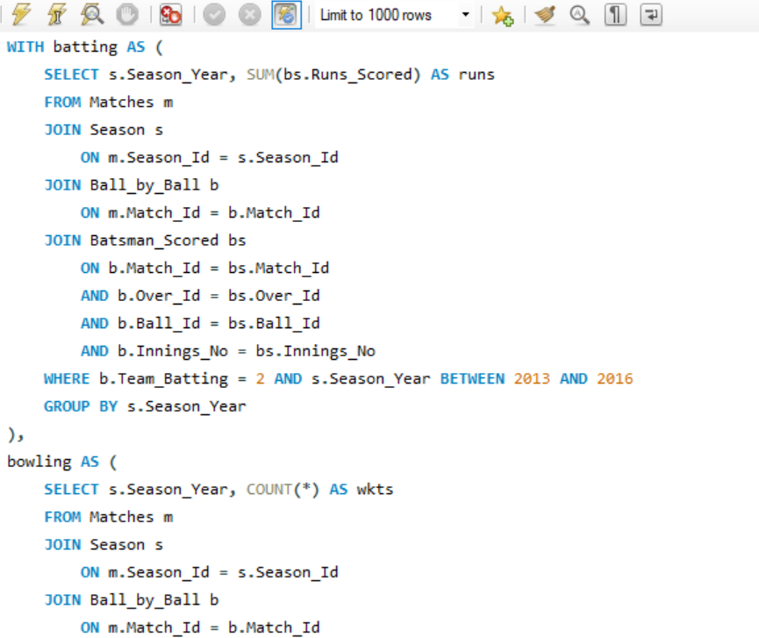
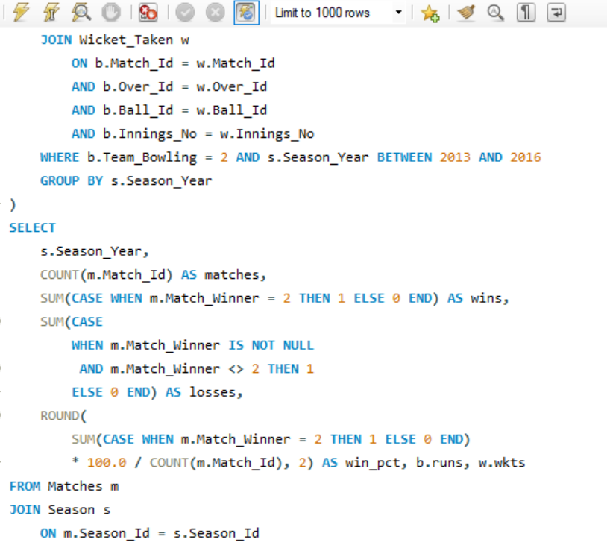
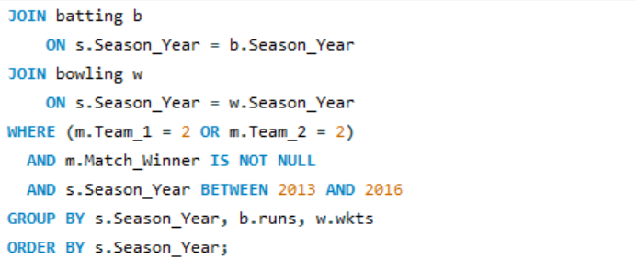
Explanation:
I used Matches and Season tables to get RCB's season-wise match results. Since RCB has Team_Id = 2, I used Team_1 = 2 OR Team_2 = 2 to identify RCB matches.
For batting performance, I joined Ball_by_Ball with Batsman_Scored and used Team_Batting = 2 to calculate RCB's total runs for each season.
For bowling performance, I used Team_Bowling = 2 and joined Wicket_Taken with the ball-level information to calculate the wickets taken by RCB.
I calculated the batting and bowling figures separately so that the joins did not duplicate the runs or wickets.

Output:
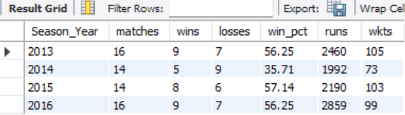

Data Visualization
1. RCB Win Percentage by Season
I created a column chart using:
- X-axis: Season
- Y-axis: Win Percentage
- Title: RCB Win Percentage by Season (2013–2016)
The chart shows that RCB's win percentage dropped significantly in 2014 and improved again in 2015.
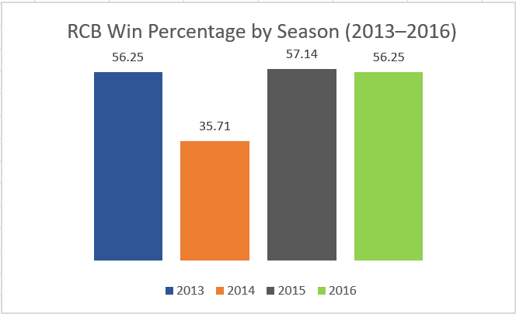
2. RCB Batting and Bowling Performance
I created a chart comparing:
- Runs
- Wickets
- Across the seasons 2013–2016
- Chart title: RCB Batting and Bowling Performance (2013–2016)
This helps compare the changes in RCB's batting output and wicket-taking performance across the four seasons.
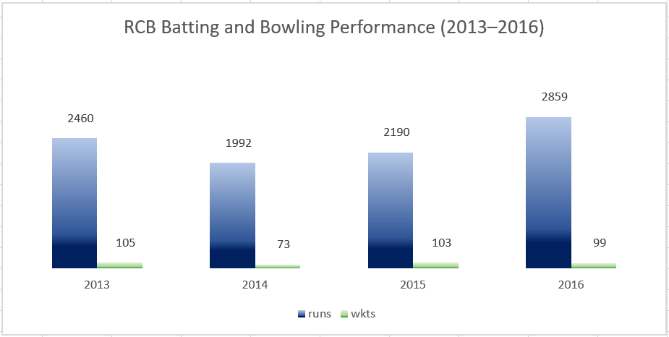
Analytical Findings:
From the analysis, I found that 2014 was RCB's weakest season. The team won only 5 out of 14 matches, giving a win percentage of 35.71%. It also had the lowest runs (1,992) and wickets (73) during the four seasons analysed.
In 2015, RCB improved considerably, winning 8 out of 14 matches with a 57.14% win percentage. The team also took 103 wickets, which was a significant improvement compared with 2014.
In 2016, RCB had its highest batting output during this period, scoring 2,859 runs. However, its win percentage was 56.25%, showing that high batting output alone did not result in a much higher winning percentage.
Overall, RCB performed reasonably well in 2013, 2015 and 2016, but the significant drop in 2014 shows that the team's performance was not consistent across seasons.

Potential Reasons for Not Winning a Trophy:
Based on my analysis, I identified the following possible reasons:
- Inconsistent performance across seasons
RCB's win percentage varied considerably, with a major decline in 2014.
- Batting and bowling balance
The results show that strong batting performance alone was not enough to consistently produce wins. Both batting and bowling needed to perform together.
- Dependence on key contributors
The player-level analysis in the project shows that some players contributed significantly to RCB's performance. Having stronger support from the rest of the squad could reduce this dependence.
- Difficulty converting strong performances into consistent results
RCB had win percentages above 56% in three of the four seasons analysed, but strong season-level performance did not necessarily translate into trophy success.

Conclusion:
Overall, my analysis shows that RCB's main challenge was maintaining consistent and balanced team performance. The 2014 season was particularly weak, with the lowest win percentage, runs and wickets. Although RCB recorded its highest batting output in 2016, its win percentage remained at 56.25%, showing that strong batting performance alone was not sufficient. Therefore, improving consistency across seasons, maintaining a better balance between batting and bowling, and reducing dependence on a few key contributors could help RCB convert strong performances into better tournament results.

Q10 How would you approach this problem, if the objective and subjective questions weren't given?
If the questions were not provided, I would approach the IPL dataset as a data analyst problem rather than trying to answer predefined questions.
1. Understand the business objective
First, I would identify the overall purpose of the analysis.
For this project, the broad objective would be:
Analyze RCB's historical performance and identify patterns that can help improve team strategy and future player selection.
2. Understand the database
I would examine the available tables and understand how they are related.
Important tables in this dataset include:
- Matches — match details, teams, winner, venue and season
- Ball_by_Ball — ball-level information, batsman and bowler
- Batsman_Scored — runs scored
- Wicket_Taken — wickets
- Player — player information
- Player_Match — players participating in matches
- Season — season information
- Venue — venue information
- Team — team information
This would help me understand what questions can actually be answered from the data.
3. Identify important KPIs
I would then decide which metrics are useful for evaluating RCB.
For example:
Team performance
- Matches played
- Wins and losses
- Win percentage
- Runs scored
- Wickets taken
- Season-to-season performance
Batting
- Total runs
- Average runs
- Strike rate
- Boundaries
- Consistency
Bowling
- Total wickets
- Average wickets
- Bowling style
- Performance by venue
Match conditions
- Venue performance
- Toss decision
- Home-ground performance
- High-scoring matches
Player contribution
- Runs
- Wickets
- Strike rate
- Consistency
- Performance when the player participated
4. Perform exploratory analysis
I would use SQL to investigate patterns such as:
- Which seasons were RCB's strongest and weakest?
- Which players contributed the most?
- Which venues were most favourable?
- Did winning the toss appear to influence results?
- Was RCB stronger in batting or bowling?
- Which players were consistent across seasons?
- Which players performed better at particular venues?
5. Create visualizations
I would convert the important findings into dashboards/charts, such as:
- Season-wise win percentage → Line/column chart
- Top run scorers → Bar chart
- Top wicket-takers → Bar chart
- Venue-wise performance → Bar chart
- Toss decision vs match result → Clustered column chart
- Batting vs bowling contribution → Scatter chart
- Season performance → KPI cards + trend charts
6. Find actionable insights
The final step would be to move beyond simply reporting numbers.
For example:
If RCB has strong batting numbers but relatively weaker bowling numbers, the analysis could suggest strengthening the bowling attack.
Or:
If RCB performs significantly better at certain venues, venue-specific player selection and match strategies could be considered.
The recommendation would always be based on the patterns found in the data, rather than assumptions.
7. Present the final analysis
I would structure the project as:
Database → Data understanding → KPIs → Exploratory analysis → SQL analysis → Visualizations → Insights → Recommendations
Conclusion
If the objective and subjective questions were not given, I would first understand the database and its relationships, define the business objective, identify relevant KPIs, perform exploratory SQL analysis, visualize important trends, and finally convert the findings into actionable recommendations for RCB. This approach ensures that the analysis is driven by the data rather than by predefined questions.

Q11 In the "Match" table, some entries in the "Opponent_Team" column are incorrectly spelled as "Delhi_Capitals" instead of "Delhi_Daredevils". Write an SQL query to replace all occurrences of "Delhi_Capitals" with "Delhi_Daredevils".

While analyzing match records for team-wise performance, I noticed that some entries in the "Opponent_Team" column were incorrectly labeled as 'Delhi_Capitals', even though the correct historical name during those seasons should have been 'Delhi_Daredevils'.
SQL Query to Fix the Incorrect Entries:
UPDATE Matches
SET Opponent_Team = 'Delhi_Daredevils'
WHERE Opponent_Team = 'Delhi_Capitals';
Explanation:
- This query goes into the Matches table.
- It searches for rows where Opponent_Team is 'Delhi_Capitals'.
- It then updates those rows to replace it with 'Delhi_Daredevils'.
This correction ensures consistency in team names, especially for reports and visualizations where grouping by team name is done.

Importance:
Without this fix, your queries might treat 'Delhi_Capitals' and 'Delhi_Daredevils' as two different teams.
This would misrepresent win/loss stats, head-to-head records, and team performance charts.

Conclusion:
By correcting the ‘team’ name using a simple SQL update, I ensured that all matches reflect the historically accurate team name.
This helps maintain data quality, and ensures that aggregated stats and insights are reliable for analysis and visualization in the project.

